**COEN 317**

**Microprocessor Systems**

**EXPERIMENT #5**

**Direct Memory Access**

**Name : Nicholas Gattuso**

**Section : U-UI**

"I certify that this submission is my original work and meets the Faculty’s Expectations of Originality",

# Objectives

The objectives of the lab are to become familiar with the Xilinx AXI Central Direct Memory Access. Additionally, it is also to gain experience with the PlanAhead tools, the Xilinx Platform Studio, and the SDK.

# Introduction

# In this lab, we are introduced to the AXI CDMA. The CDMA allows for data transfers from a memory source to a memory destination at high speeds. In this lab, we will instantiate the CDMA as a master device to control two high-performance slave ports. These high-performance ports are the Master General Purpose port and will be connected using the AXI Interconnect instance. As a result, we will be able to provide high throughput of data between the AXI master and the processor's DDR memory system.

Additionally, one question of this lab ask us to find the time it takes to transfer the data. This will be done with the AXI Timer, which we have seen in lab 3. The timer is a timer module that counts the clock sequence. We’ve seen three different modes to use the timer in.

For more information, please refer to the lab manual.

# Results

The hardware in the first part can be configured by following the steps in the lab manual. In short, those steps tell us to add an instance of CDMA and two instance of AXI interconnect (one for gp and one for hp). Additionally, we manually made the connections rather than use the processor system 7 manual connection. The lab manual explained a few ways to make the connections, but simply, in the bus tab, we can click the square and circle boxes for the ports we want as master and slave. With the hardware configured, the program could've been written on the Xilinx SDK; the following is the main.cc code to perform the data transfer between the source and destination. Note, the lab manual provides us with the step breakdown in pseudocode for the program.

#include "xil_exception.h"

#include "xil_cache.h"

#include "xparameters.h"

#include <iostream>

using namespace std;

int main()

{

//initialize the three pointers

u32* cdma_ptr = (u32*) XPAR_AXI_CDMA_0_BASEADDR;

u32* source_ptr = (u32*) XPAR_PS7_DDR_0_S_AXI_HP0_BASEADDR;

u32* destination_ptr = (u32*) XPAR_PS7_DDR_0_S_AXI_HP2_BASEADDR;

//initializing the contents of the source array within the maximum size

for(int i =0; i <= 32; i++)

{

*(source_ptr + i) = i;

}

//initializing the contents of the destination array

for(int i =0; i <= 32; i++)

{

*(destination_ptr + i) = -i;

}

//reset the cdma

*(cdma_ptr) = 0x00000004;

//configure the cdma

*(cdma_ptr) = 0x00000020;

//load address of source array

*(cdma_ptr + 6) = 0x20000000;

//load address of destination array

*(cdma_ptr + 8) = 0x30000000;

//flush the cash

Xil_DCacheFlush();

//number of bytes to transfer

*(cdma_ptr + 10) = 0x64;

//take in a value to start the process

char dummy;

cout << "Enter a key to begin" << endl;

cin >> dummy;

int status_reg_val = *(cdma_ptr + 1) & 2;

while(status_reg_val == 0)

{

status_reg_val = *(cdma_ptr + 1) & 2; //isolate the idle bit

if(status_reg_val == 2){ break; } //break when idle bit is 1

}

bool are_equal = true;

//compare the contents after the transfer

for(int i=0 ; i <= 32; i++)

{

if(*(destination_ptr + i) != *(source_ptr + i))

{

are_equal = false;

}

}

//output the result

if (are_equal){ cout << "The values in the source and destination array are equal!" << endl;}

else { cout << "The values in the source and destination array are not equal!" << endl;}

return 0;

}

When running the program, we get the following results:

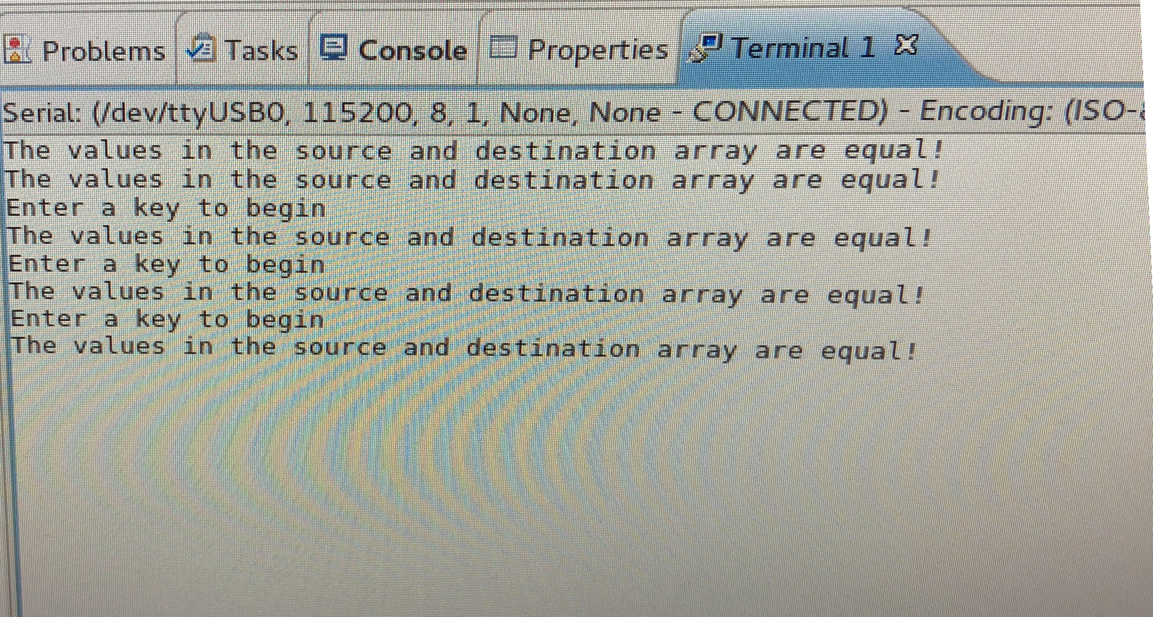

# Questions

**1.**

This question asks us to use an AXI timer to find the time it takes to transfer the data. To do this, we can modify the hardware by adding an instance of AXI Timer/Counter. To make things simple, we can let the connections be done using the processor's system 7. However, we can manually connect them by following the same process we saw in the first part. In terms of modifying the program on SDK, I referred to lab 3 where we used the timer to count how many cycles it took for a discrete write. For this lab, instead of a discrete write, we are doing a data transfer with the CDMA. Using the code from part 1, I modified it by adding a timer variable, initialize it, set it in capture mode (because we are just getting a count), start the timer, and end the timer. The following is the modified code:

#include "xil_exception.h"

#include "xil_cache.h"

#include "xparameters.h"

#include <iostream>

#include "xtmrctr.h"

using namespace std;

int main()

{

//-------------------------------------------------------Declare variables------------------------------------

//declare the three pointers

u32* cdma_ptr = (u32*) XPAR_AXI_CDMA_0_BASEADDR;

u32* source_ptr = (u32*) XPAR_PS7_DDR_0_S_AXI_HP0_BASEADDR;

u32* destination_ptr = (u32*) XPAR_PS7_DDR_0_S_AXI_HP2_BASEADDR;

//declare the timer pointer

XTmrCtr TimerInstancePtr;

//--------------------------------------------------------Initialize the variables------------------------------------------------

//initializing the contents of the source array within the maximum size

for(int i =0; i <= 24; i++)

{

*(source_ptr + i) = i;

}

//initializing the contents of the destination array

for(int i =0; i <= 24; i++)

{

*(destination_ptr + i) = -i;

}

//----------initialize the axi timer

xStatus = XTmrCtr_Initialize(&TimerInstancePtr, XPAR_AXI_TIMER_0_DEVICE_ID);

if(xStatus != XST_SUCCESS)

{

cout << "TIMER INIT FAILED" << endl;

return 0;

}

//setting the timer reset value

XTmrCtr_SetResetValue(&TimerInstancePtr, 0, 0);

//setting the timer option

XTmrCtr_SetOptions(&TimerInstancePtr, XPAR_AXI_TIMER_0_DEVICE_ID, XTC_CAPTURE_MODE_OPTION);

//reset the cdma

*(cdma_ptr) = 0x00000004;

//configure the cdma

*(cdma_ptr) = 0x00000020;

//load address of source array

*(cdma_ptr + 6) = 0x20000000;

//load address of destination array

*(cdma_ptr + 8) = 0x30000000;

//flush the cash

Xil_DCacheFlush();

//number of bytes to transfer

*(cdma_ptr + 10) = 0x64;

//----------------------------------------------------main operations------------------------------------------

//take in a value to start the process

char dummy;

cout << "Enter a key to begin" << endl;

cin >> dummy;

//start the timer

XTmrCtr_Start(&TimerInstancePtr, 0);

//begin transfer

int status_reg_val = *(cdma_ptr + 1) & 2;

while(status_reg_val == 0)

{

status_reg_val = *(cdma_ptr + 1) & 2; //isolate the idle bit

if(status_reg_val == 2){ break; } //break when idle bit is 1

}

//transfer ends, stop timer and get the count

XTmrCtr_Stop(&TimerInstancePtr, 0);

unsigned int count = XTmrCtr_GetValue(&TimerInstancePtr, 0);

bool are_equal = true;

//compare the contents after the transfer

for(int i=0 ; i <= 32; i++)

{

if(*(destination_ptr + i) != *(source_ptr + i))

{

are_equal = false;

cout <<"The destination and source value are not the same : " << *(destination_ptr + i) << " " << *(source_ptr + i) << endl;

}

else {

cout <<"The destination and source value are the same : " << *(destination_ptr + i) << " " << *(source_ptr + i) << endl;

}

}

//output the results

if (are_equal){ cout << "The values in the source and destination array are equal!" << endl;}

else { cout << "The values in the source and destination array are not equal!" << endl;}

cout << " It required " << count << " clock cycles to transfer the data " << endl;

return 0;

}

For some unknown reason, my 'xtmr.ctr.h' file couldn't be found. Even after trying to rebuild the project, the SDK still couldn’t find it. Since I'm not the one that added that file to the system, I don't know the location that its stored. For that reason, I couldn't go find it and move it into the project's directory. As a result, I was unable to actually run my code on the program to get the count and complete the question. The following is the error message for the header file as proof that I couldn't complete the question because of the system.

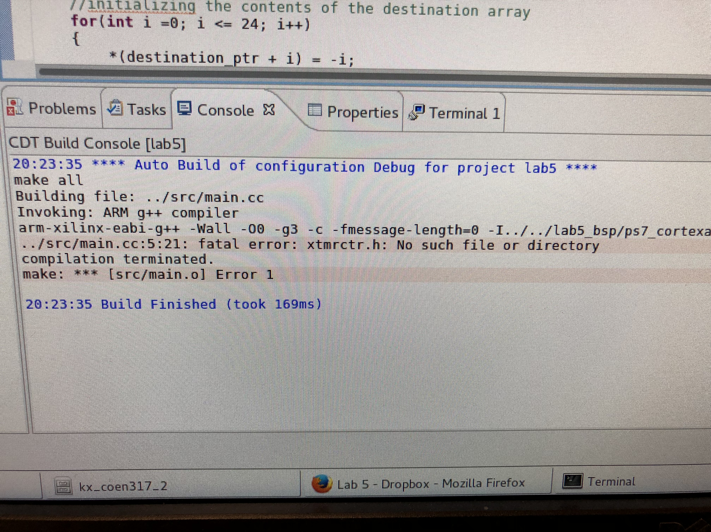

**2.**

We are only allowed to write to the first 25 bits of the BBT register. What happens if we program to write above the maximum allowed? The easiest way to answer this question is by modifying the code in part 1 to write the data pass the maximum bits. Additionally, we can modify the code to show the results as it compares the source with the destination so that we can see in more detail what happens. The following is the modified code:

#include "xil_exception.h"

#include "xil_cache.h"

#include "xparameters.h"

#include <iostream>

using namespace std;

int main()

{

//initialize the three pointers

u32* cdma_ptr = (u32*) XPAR_AXI_CDMA_0_BASEADDR;

u32* source_ptr = (u32*) XPAR_PS7_DDR_0_S_AXI_HP0_BASEADDR;

u32* destination_ptr = (u32*) XPAR_PS7_DDR_0_S_AXI_HP2_BASEADDR;

//initializing the contents of the source array within the maximum size

for(int i =0; i <= 32; i++)

{

*(source_ptr + i) = i;

}

//initializing the contents of the destination array

for(int i =0; i <= 32; i++)

{

*(destination_ptr + i) = -i;

}

//reset the cdma

*(cdma_ptr) = 0x00000004;

//configure the cdma

*(cdma_ptr) = 0x00000020;

//load address of source array

*(cdma_ptr + 6) = 0x20000000;

//load address of destination array

*(cdma_ptr + 8) = 0x30000000;

//flush the cash

Xil_DCacheFlush();

//number of bytes to transfer

*(cdma_ptr + 10) = 0x64;

//take in a value to start the process

char dummy;

cout << "Enter a key to begin" << endl;

cin >> dummy;

int status_reg_val = *(cdma_ptr + 1) & 2;

while(status_reg_val == 0)

{

status_reg_val = *(cdma_ptr + 1) & 2; //isolate the idle bit

if(status_reg_val == 2){ break; } //break when idle bit is 1

}

bool are_equal = true;

//compare the contents after the transfer

for(int i=0 ; i <= 32; i++)

{

if(*(destination_ptr + i) != *(source_ptr + i))

{

are_equal = false;

cout <<"The destination and source value are not the same : " << *(destination_ptr + i) << " " << *(source_ptr + i) << endl;

}

else {

cout <<"The destination and source value are the same : " << *(destination_ptr + i) << " " << *(source_ptr + i) << endl;

}

}

//output the result

if (are_equal){ cout << "The values in the source and destination array are equal!" << endl;}

else { cout << "The values in the source and destination array are not equal!" << endl;}

return 0;

}

When running the code we get the following results. It can be seen that when writing pass the maximum bits, the destination data doesn't get modified. This should be occurring because bits 26 to 32 are reserved and shouldn't be modified.

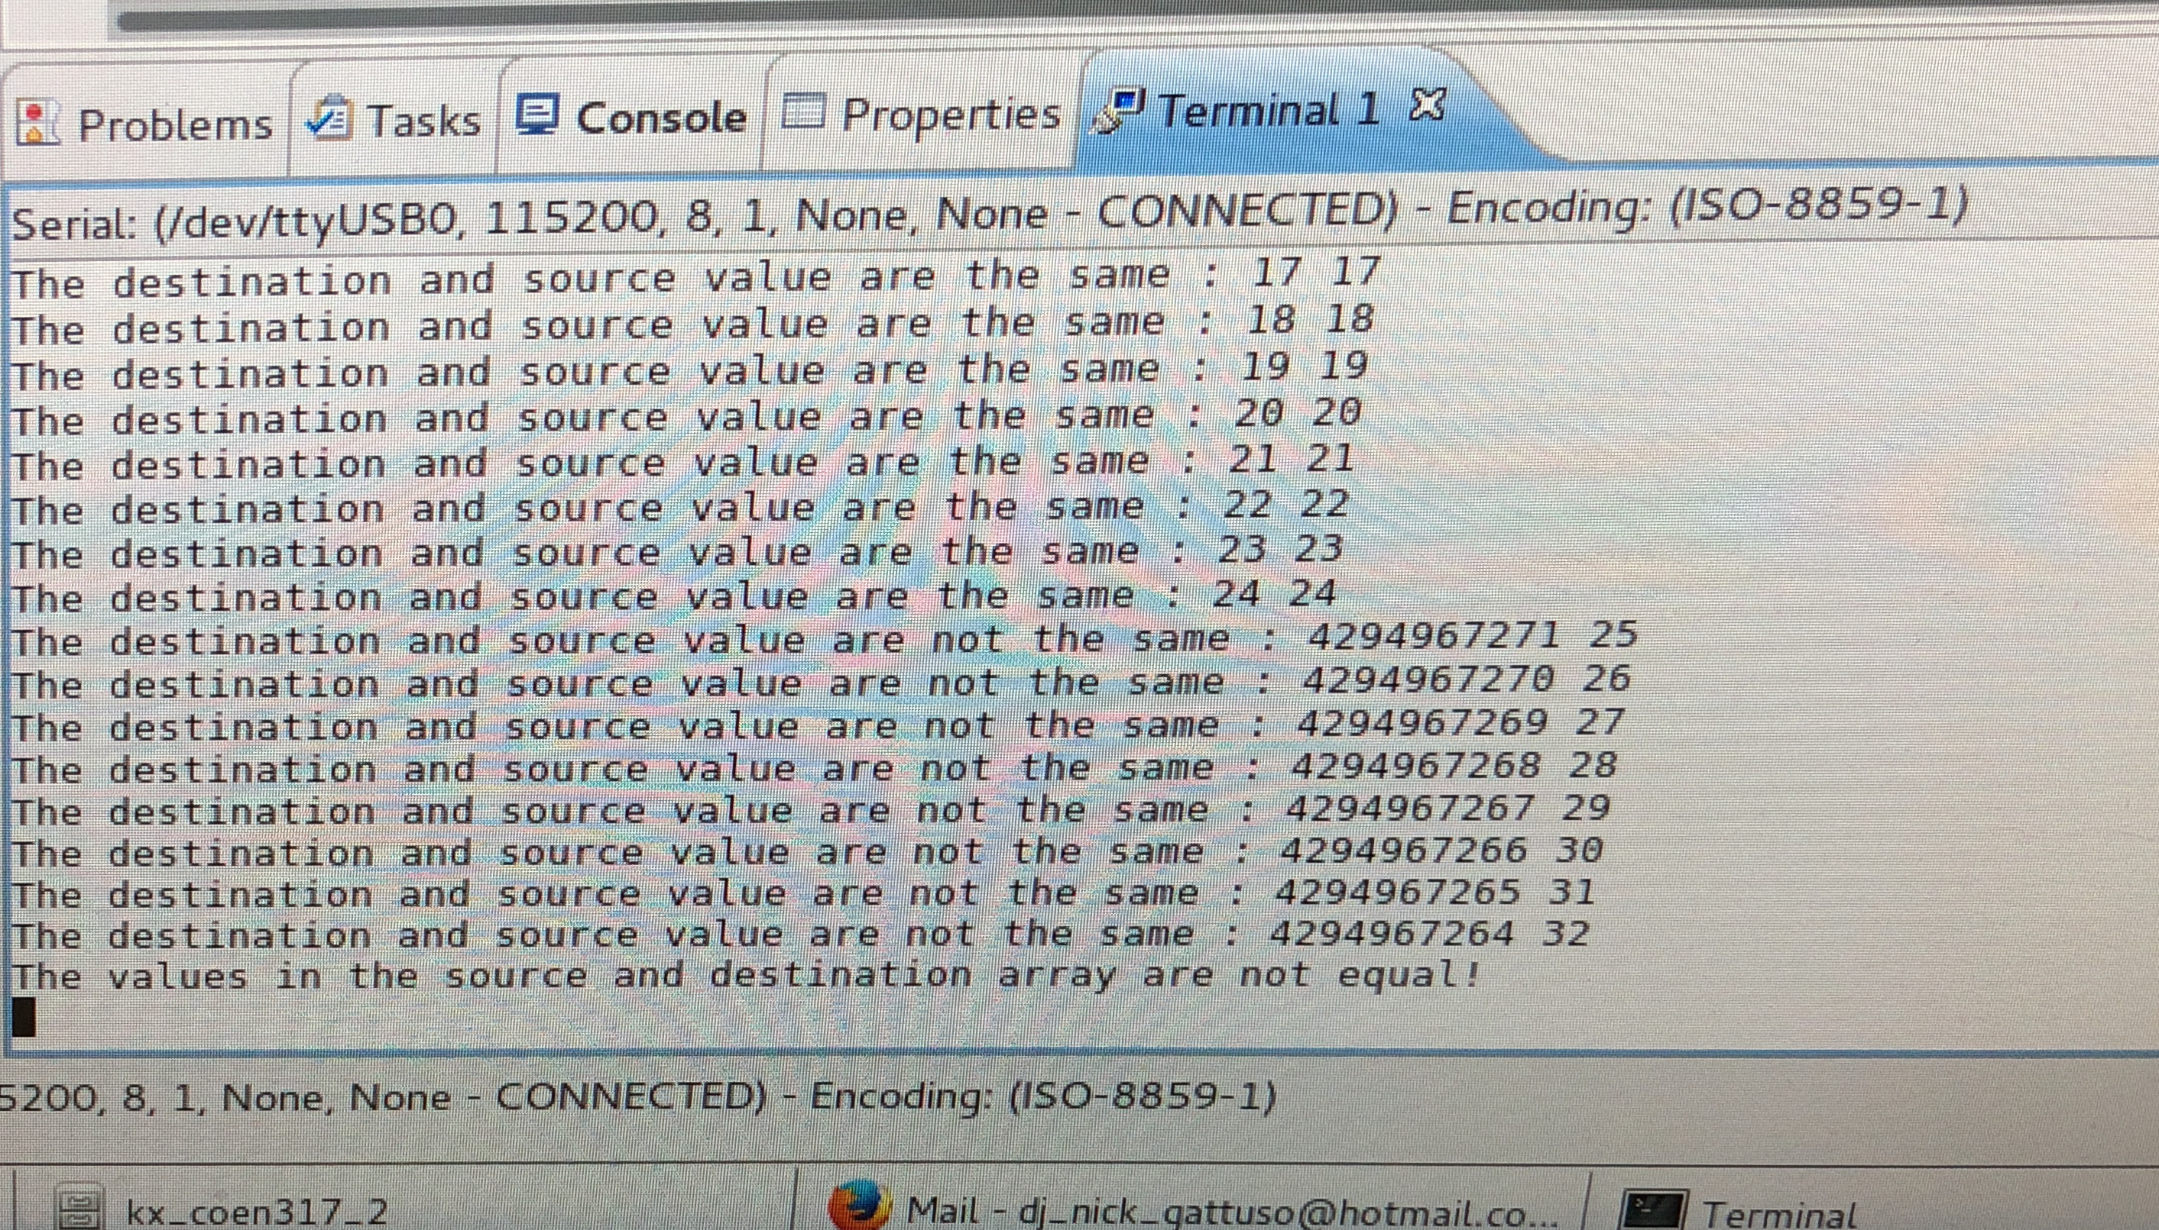

# Conclusion

In conclusion, the objectives of the lab were met. I managed to gain experience using the AXI CDMA and to further my experience using the AXI Timer.